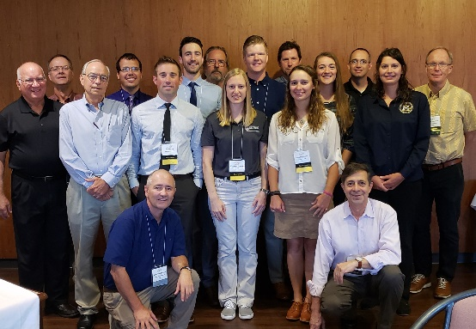
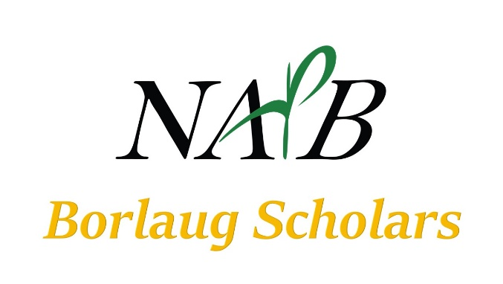
2018 NAPB Scholars and Mentors

July 1, 2019 (1st Draft)
NAPB Borlaug Scholars Committee (no change in leadership is anticipated for 2019-20):

Donn Cummings, Chair
Don Jones, Vice Chair
Allen Van Deynze, Secretary
Bo Zhang, Member
Wayne Smith, Member
Jodi Scheffler, Member

Vision: A sustainable annual flow of high-potential plant science students and emerging plant breeders into the professional community.
Mission: Selection of outstanding plant breeding students through national competition; funding of these students to attend the NAPB Annual Meetings; mentoring of scholarship recipients by accomplished members during and after the annual meeting.
Goal 1: Identify and encourage outstanding collegiate students with aspirations of becoming professional plant breeders
Goal 2: Provide opportunities for NAPB members to mentor emerging talent in the plant breeding profession
Goal 3: Manage all aspects of the NAPB Borlaug Scholarship travel grants and mentoring program and to report status regularly to the NAPB executive committee and membership, and to the public.

2018-2019 Accomplishments:

- Student scholarship nominations increased from 50 to 71 (up 142% over prior year)
- Scholarship awards Increased from 8 to 12 for 2019 (up 150% over prior year)
- The NAPB/ASF Borlaug Scholarship Fund received $54,112.40 (incudes the initial $30K) and paid out $11,014.04 in expenditures in calendar year 2018 funding 8 scholarships.
- A donor matching gifts opportunity was promoted to NAPB individual members in Fall 2018 and July 2019.
- Contributions to the fund in the first half of 2019 are approximately $10,000 by June 30. This includes institutional gifts exceeding $1K each, from Cotton, Inc. SIPA, TAMU, and Bayer.
- A marketing logo for promoting the NAPB Borlaug Scholars program was created with input from our graduate students.
- NAPB Borlaug Scholars Booth and marketing materials were created and displayed at the NAPB Annual Meetings Guelph, Aug 2018; ASTA Chicago, Dec 2018 and ASTA Orlando, Feb 2019; and at ASHS Annual Meetings, Jul 2019. A pop-up display banner was created and purchased to support the NAPB booth exhibits.
- The committee collaborated with Germination (Canada) and Seed World (US) Magazines to publicize our program.
Examples: Kevin Falk was on cover of Germination Nov 2018 issue featuring the Grateful Eight (our 2018 NAPB Borlaug Scholars). Podcasts interviews made during the 2018 NAPB Annual Meetings of all eight NAPB Borlaug Scholars and some mentors which were then promoted. Three Borlaug Scholars, Adam Bolton, Austin Dobbels and Katelyn Fritz were on the cover of Seed World and featured in “Top 20 Under 30” article in the June 2019 issue.
- Our committee developed a Standard Operating Practices (SOP) document to guide future participants and leadership.
- A letter outlining desired changes to the NAPB website to centralize and enhance the user experience was submitted to the Executive Committee.
- Two new committee members were added in Fall 2018: Wayne Smith and Jodi Scheffler

Future needs, plans, and activities:

- The committee recognizes the need to add participants to the review and selection team due to increasing workload as the program grows. Nominations are being accepted.
- We plan to increase the number of scholarships by 2 per year on average during the next 5yr plan.
- Fund raising efforts need to be increased to meet our aggressive program growth goals. Both member and institutional donations need to increase. Over time, the NAPB/ASF Borlaug Scholars Fund needs to become endowed to be more self-sustaining through investment earnings. Additional fundraising programs are under development.
- Website enhancements are needed to support the Borlaug Scholars program in a more user-friendly experience for online visitors. This needs to be coordinated with broader overhaul of the NAPB website.
- The mentoring program associated with NABP Borlaug Scholars needs to grow proportional with the overall program growth. Plans to create communications that will appeal to member volunteerism for mentoring are underway.
- Promoting the NAPB Borlaug Scholarship program to a broader public is an ongoing need/goal. We are promoting Borlaug Scholarships through campus symposia, partner associations, direct emails, e-newsletters, and through social media in partnership with the communications committee and through our website.
- Grow our presence at partner trade shows and expos (e.g., CSSA; ASTA), in supportive media outlets (e.g., Seed World and Germination, Issues, Inc.), where opportunities to partner are greatest, and with other organizations

