PRESS RELEASE

10 August 2018

National Association of Plant Breeders Recognizes Peers and Students

At its 2018 annual meeting, the National Association of Plant Breeders (NAPB) presented three awards in recognition of Lifetime Achievement, Plant Breeding Impact, Early Career Scientist. In addition, XXX awards were presented to graduate students for the top posters at the conference. Hosted by the University of Guelph, Guelph, Ontario, Canada from 7-10 Aug, the meeting was held in coordination with the annual meeting of the US Plant Breeding Coordinating Committee (PBCC) and attracted over 250 participants, including over 100 students.

Awardee Summary
The 2018 NAPB awardees exemplify the very best in plant breeding research, education, outreach and leadership. They model persistent dedication and a passionate devotion to applying their plant breeding skills and technical excellence to promote food security, quality of life, and a sustainable future. They are committed to supporting the next generation of the plant breeding discipline. These outstanding professionals inspire plant breeders and scientists everywhere.

All three will present invited talks at the next NAPB/PBCC annual meeting, to be hosted by the University of Georgia, from 25-29 Aug in Pine Mountain, Georgia.

Lifetime Achievement Award: Shawn Kaeppler

This award, recognizing distinguished long-term service to the plant breeding discipline through research, teaching, outreach, and leadership, was given to Dr. Shawn Kaeppler, a Professor of Agronomy at the university of Wisconsin Madison.

Kaeppler received his B.S. degree in Genetics at the University of Wisconsin-Madison in 1987, and his Ph.D. degree in Plant Breeding and Plant Genetics at the University of Minnesota under the mentorship of Ronald Phillips. He was a faculty member at the University of Nebraska-Lincoln from 1992 to 1995 in the role of Plant Cytogeneticist. He has been a faculty member in the Department of Agronomy at the University of Wisconsin-Madison since 1995 working in the areas of Maize Genetics and Breeding and Crop Functional Genomics.

He has served as the Director of the Wisconsin Crop Innovation Center since 2016. Kaeppler is a Fellow of the Crop Science Society of America and has been recognized as a Rothermel-Bascom Professor and Campbell-Bascom Professor at the University of Wisconsin-Madison. He has served as Editor of Crop Science, on the Maize Genetics Executive Committee, on the Genomes to Fields Executive Committee, and is incoming president-elect of the Crop Science Society of America.

Kaeppler has taught graduate and undergraduate courses in plant breeding and plant genetics, including an undergraduate Plant Breeding and Biotechnology course that introduced a number of students into careers in plant breeding.

From a childhood that included judging dairy cattle, Kaeppler has been fascinated by genetics and breeding. An overall passion has been understanding how genetic variation results in altered phenotypes, and how that knowledge can be harnessed to make better crops. His collaborative team has made significant discoveries in crop epigenetics, somaclonal variation, and crop genome composition including extensive presence-absence variation. He has made important discoveries in maize seed size and composition, and maize abiotic stress tolerance.

As outcomes of his research goals, he develops maize lines with utility to seed producers in the northern maturity zones. His team at the Wisconsin Crop Innovation Center develops transformation and editing approaches for many crops including new genotype-independent approaches for previously recalcitrant crop species. Dr. Kaeppler accepts this award recognizing the strengths of his amazing colleagues, collaborators, students and staff throughout his career. Discoveries made as part of a strong team effort are always the most fulfilling and enjoyable.

Images: Shawn Kaeppler



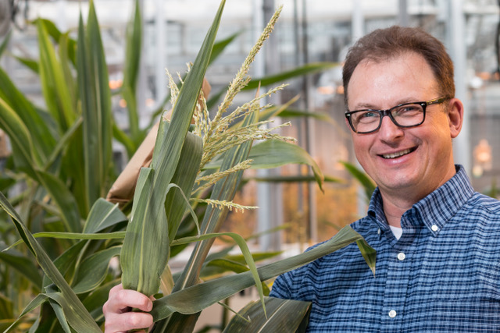
Dr. Shawn Kaeppler, Campbell Bascom Professor of Agronomy, University of Wisconsin-Madison, and 2018 recipient of the NAPB Lifetime Achievement Award.

Plant Breeding Impact Award: Donald Bockelman

This award recognizes an individual in the public or private sector who has made significant advancements in the field of plant breeding, specifically in the area of applied variety and/or technology development. The 2018 recipient is Donald Bockelman, a corn breeder who retired from Monsanto in July, 2018 after 37 years of highly impactful pant breeding activities.

Don began his career in Farmer City-IL with O’s Gold in August 1980, upon the completion of a graduate degree in Plant Pathology, working on Goss’ Wilt. After the 1984 Upjohn Purchase of O’s Gold, and integration with Asgrow, he moved to Monmouth-IL in 1987 where he remained until his retirement this last July breeding corn with focus on the central Corn Belt.

Along his career Don has also played key roles beyond corn breeding, earlier in his career as a plant pathologist providing technical and disease inoculum production support for Asgrow corn breeding, later as part of the Monsanto breeding Technology organization Don was involved in the discovery of QTL’s for disease resistance, control of flowering time, Photoperiod response and general trait-marker association analyses in Temperate/Tropical breeding populations.

Don has had a very successful track record at the challenging task of developing commercial lines containing exotic germplasm and has developed 25 PVP corn variety patents contributing to multiple hybrid PVP patents, and has also contributed on three patents involving breeding methodology.

Inbreds developed by Don represented step changes in Monsanto’s product performance for North America and have had significant relevance outside NA as part of the global germplasm exchange. If we were to grow in a single year all hybrids containing inbreds developed by Don along his career, we will cover a significant portion of the Central Belt market.

The focus for most of his career has been introgressing diverse global germplasm into North American temperate germplasm. He played a major role in managing, evaluating germplasm, and promoting diversity efforts within Monsanto. In his breeding role, multiple breeding methodologies were explored using conventional, DH, and molecular breeding schemes. He coordinated Monsanto's in-kind breeding and testing support to USDA-ARS Germplasm Enhancement of Maize (GEM).

Don developed his interest on diverse germplasm early in his career as a research assistant and plant pathology graduate student at Kansas State University, where he assisted in research on two then emerging corn disease threats in the late 70's, Goss's bacterial wilt and corn lethal necrosis. Don explored exotic germplasm as sources of disease resistance to temperate germplasm.

Equally important to his commercial success are his contributions to promote breeding for diversity efforts around the world and mentoring many new corn breeders and research team members. People from every world region have enjoyed spending time with Don in the field and have benefited from his passion for corn breeding, knowledge of global germplasm, and perspective on diversity breeding.

Along his career, Bockelman has received multiple Monsanto recognitions including the Above and Beyond Award for the germplasm team effort, Commercial Impact Award, multiple Best New Inbred Code Awards and the Career Award for outstanding lifetime achievements.

Images: Donald Bockelman

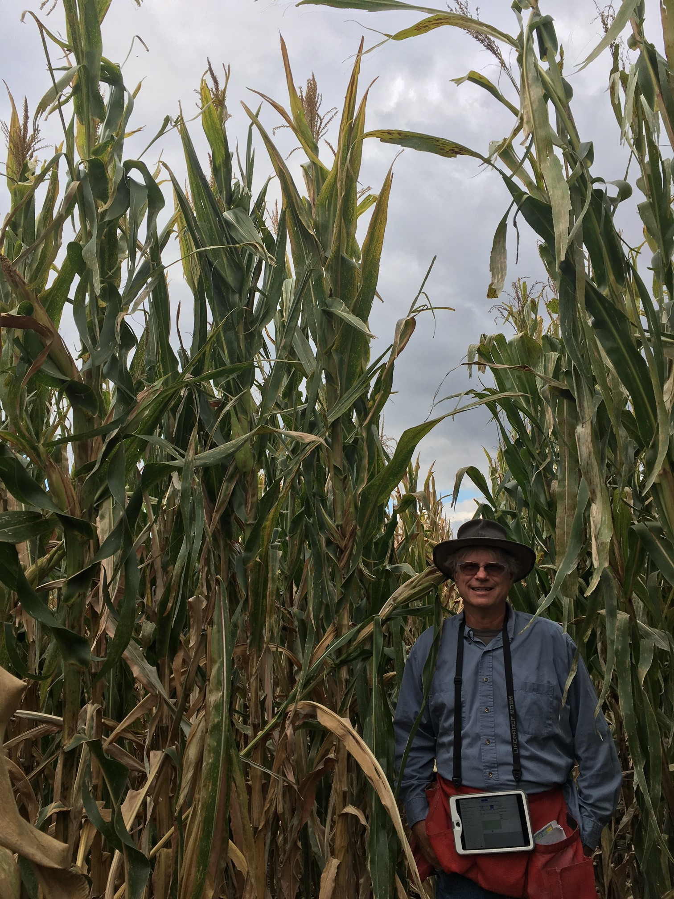


Donald Bockelman, recently-retired corn breeder for Monsanto and recipient of the 2018 NAPB Plant Breeding Impact Award.

Early Career Scientist Award: Jeffrey Endelman

This award recognizes a scientist in early stages of their plant breeding career who exhibits the ability to establish strong research foundations, to interact with multi-disciplinary teams, and to participate in relevant professional societies.

The 2018 recipient of the NAPB Early Career Scientist Award is Dr. Jeff Endelman, Assistant Professor at the University of Wisconsin-Madison and leader of the potato breeding program.

Endelman studied computational science for many years before discovering his calling as a plant breeder. As a graduate student in bioengineering at Caltech, he developed computational methods to optimize the in vitro evolution of enzymes and spent many weekends observing native plants in the wilderness areas of southern California.

Endelman left academia for two years to work on small vegetable farms, by which time he realized a career in plant breeding was the perfect way to combine his interests. He returned to graduate school to complete a PhD in Crop Science at Washington State University, where he conducted research on barley breeding and genetics. Toward the end of his PhD he created the software package rrBLUP for genome-wide prediction, which has been cited over 500 times. As a postdoc at Cornell University, he continued to research genomic selection by improving its theoretical foundation for inbred lines and investigating the optimal allocation of resources.

In 2013 Endelman joined the faculty at the University of Wisconsin-Madison to lead the potato breeding program. Over the past five years, he has overseen the release of 10 potato varieties, spanning all US market categories (chip; French fry; russet, red, and yellow fresh market).

One of the challenges with commercial potato is that it is autotetraploid, meaning the genome is organized in groups of four homologous chromosomes rather than homologous pairs. The Endelman group has developed several tools to facilitate molecular breeding in autotetraploids, including software to determine allele dosage for SNP array and GBS markers, software for genome-wide association analysis, and methods to partition genetic variance. In 2018 UW-Madison became the first potato breeding program in North America to implement genomic selection, based on a training set of 570 clones.

Endelman has been active in training students and postdocs at UW-Madison. He teaches an undergraduate course on “Genetically Modified Crops” and graduate courses on genetic mapping, polyploid genetics, and selection theory. One MS student, one PhD student, and three postdocs have been trained in his lab so far, and he has served on the thesis committee of 14 other graduate students.
Images: Jeffrey Endelman



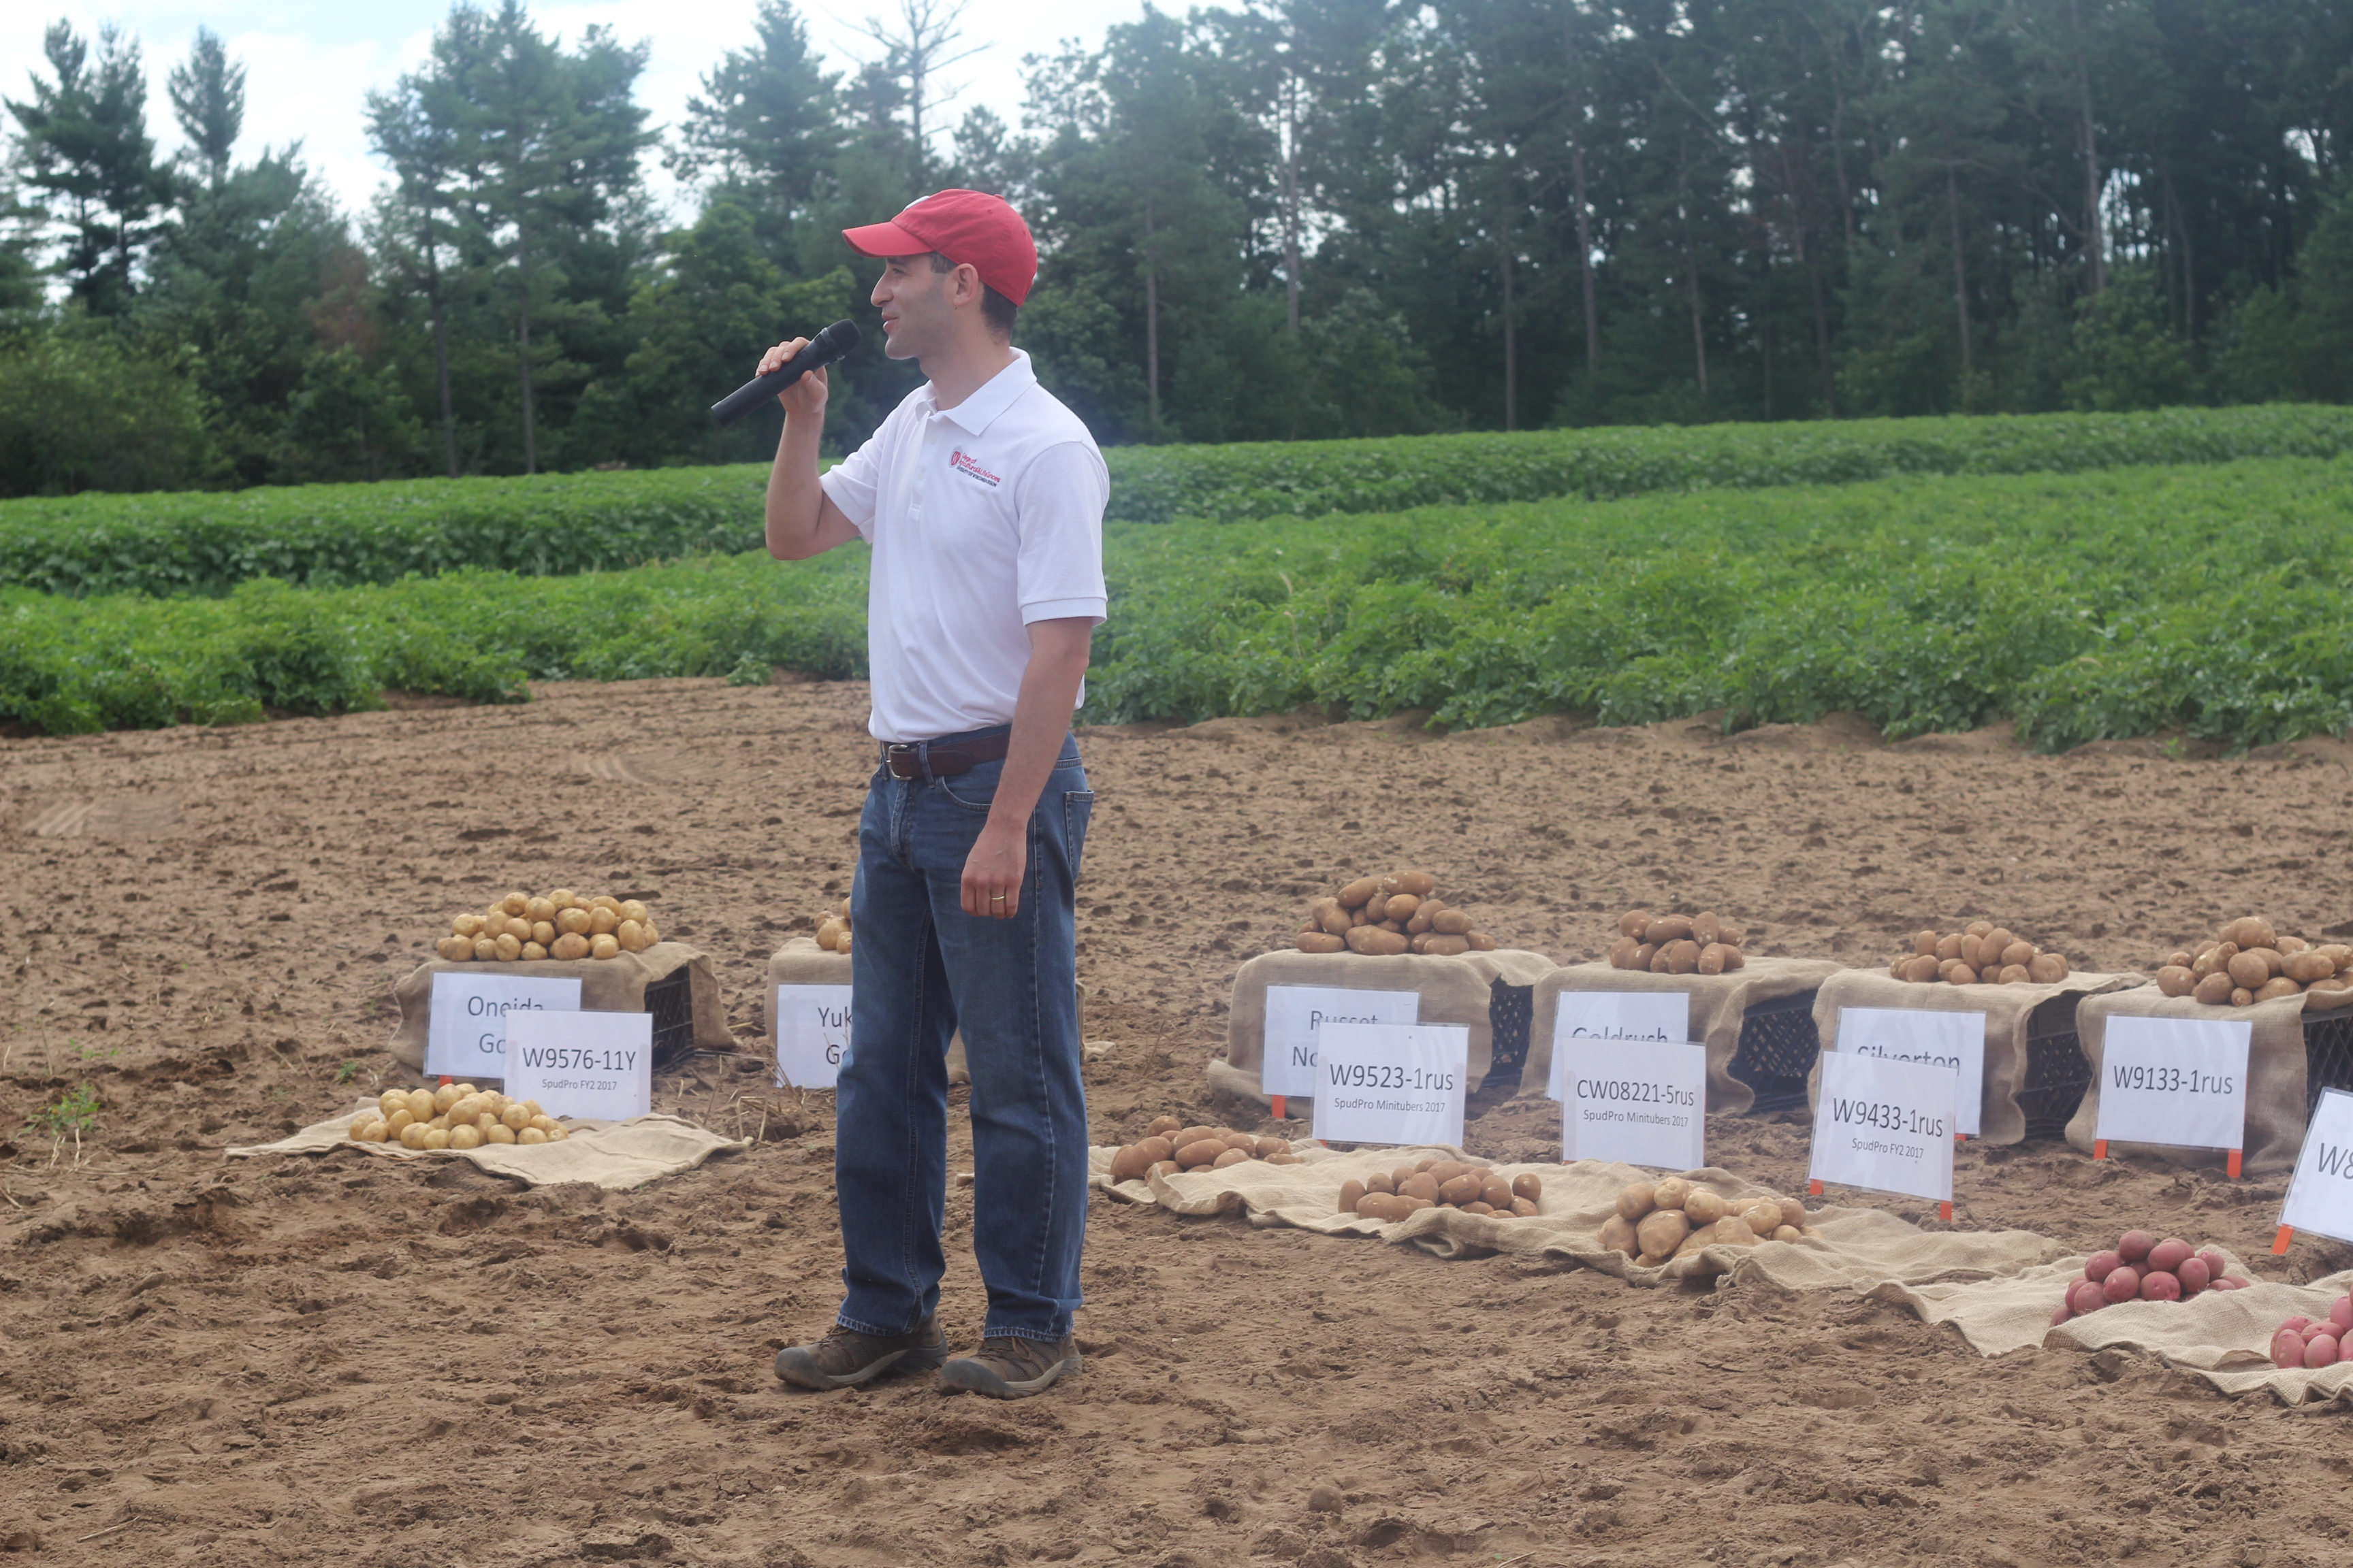
Dr. Jeffrey Endelman, Assistant Professor, University of Wisconsin-Madison, and recipient of the NAPB 2018 Early Career Scientist Award.
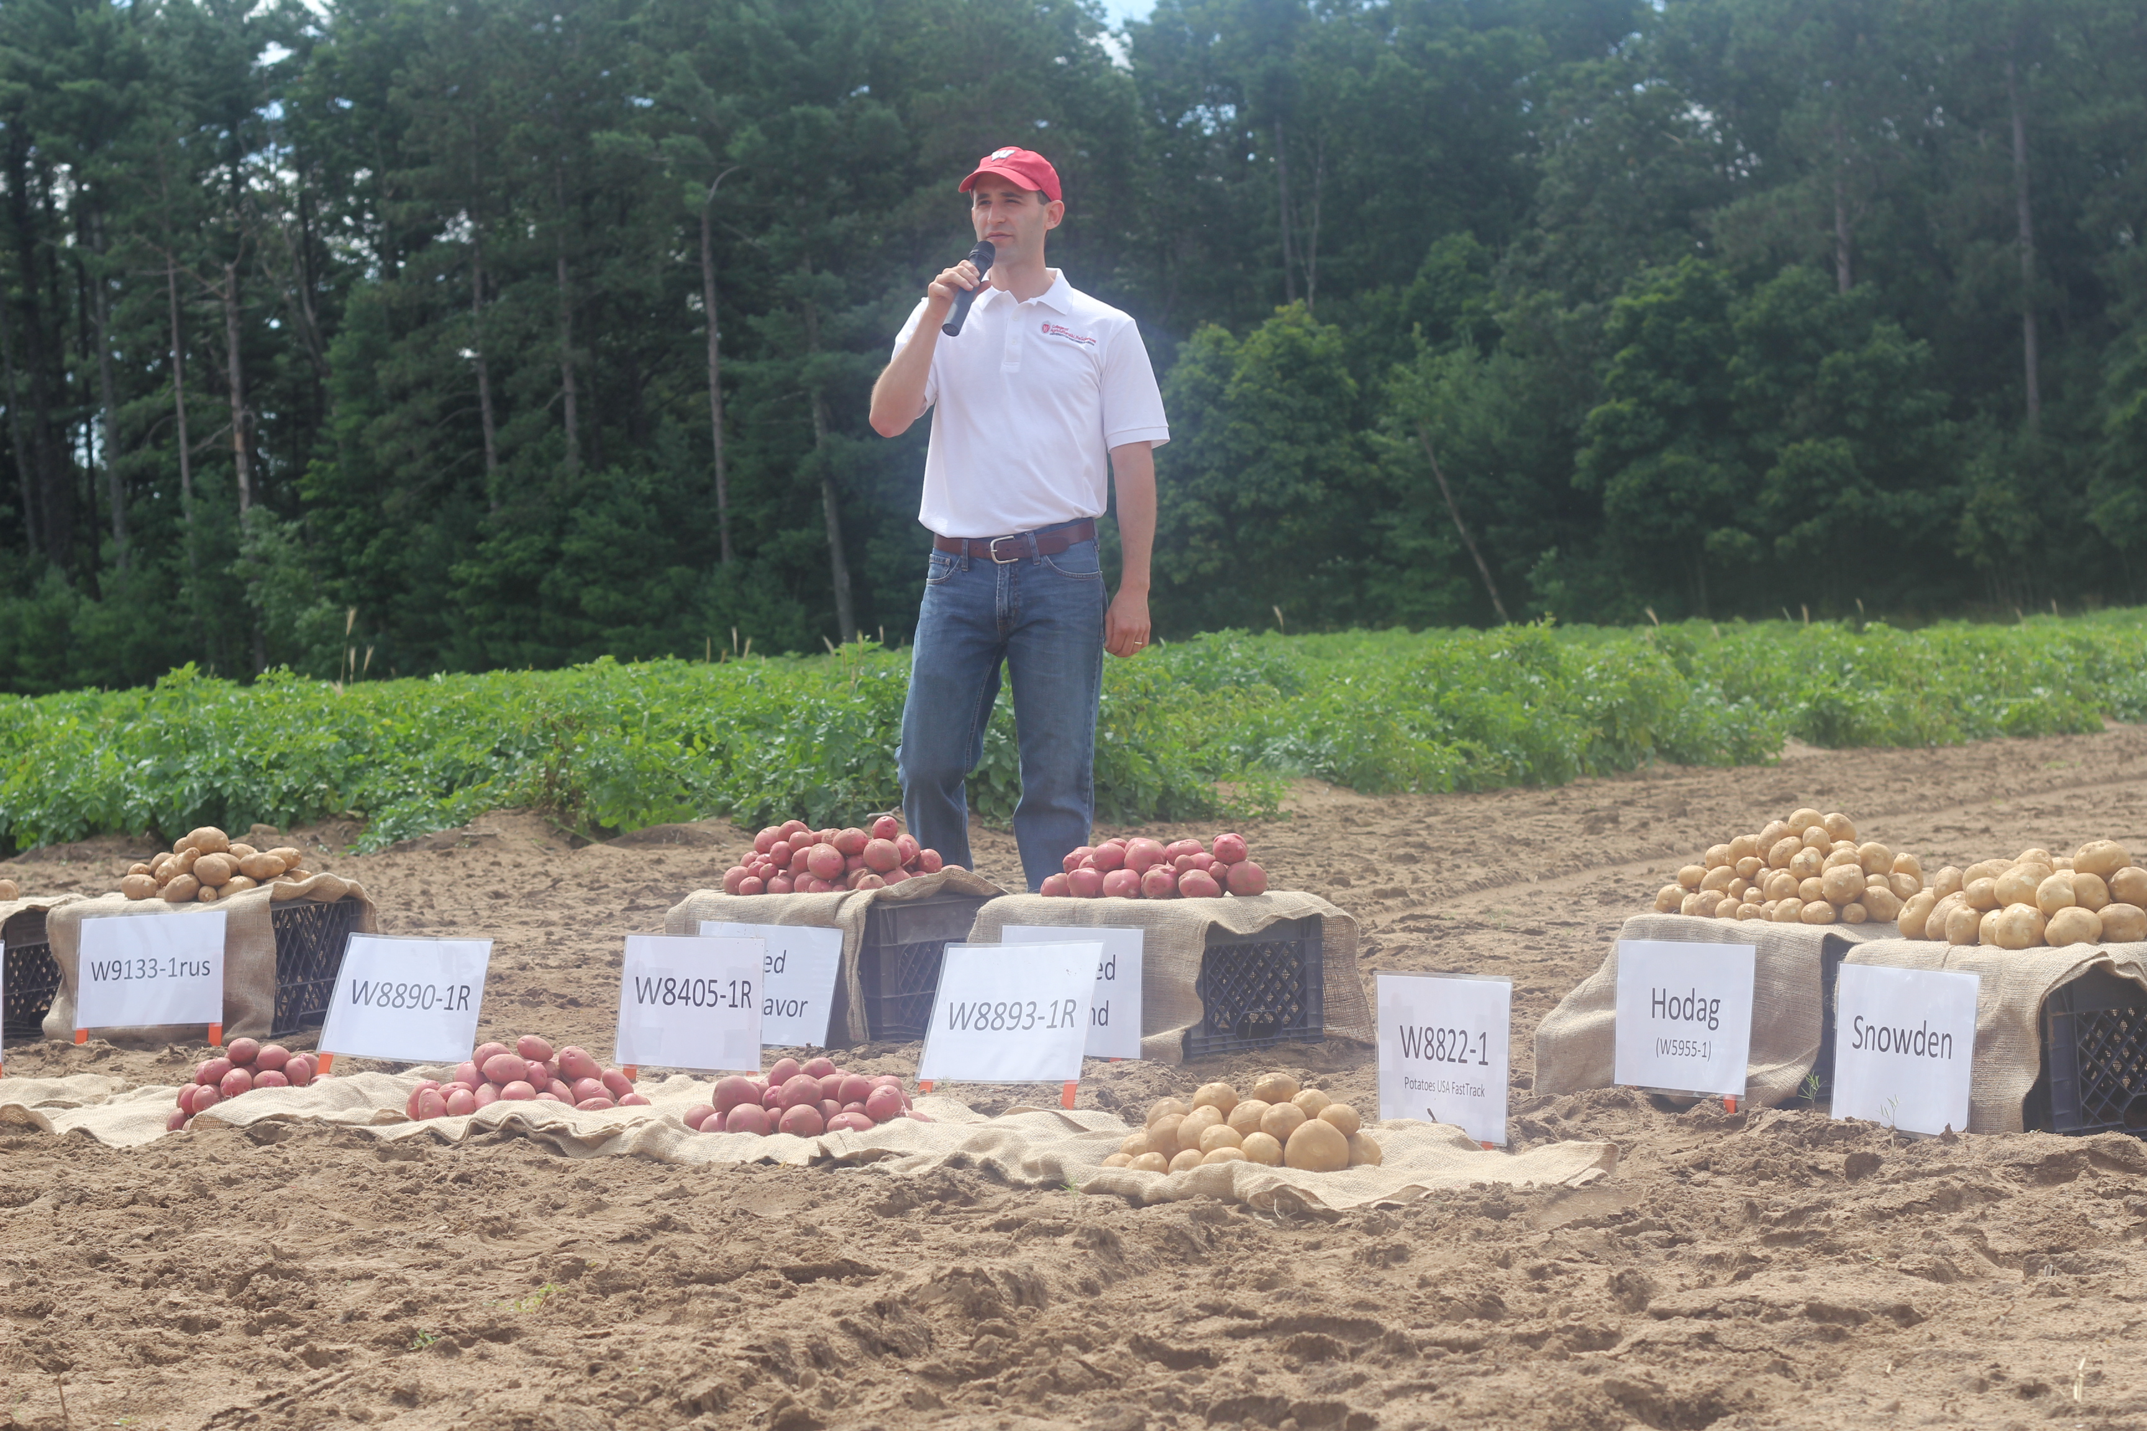

Graduate Student Poster Awardees
Need to get image and text for these awardees.

Borlaug Scholars

Need to get text and images.

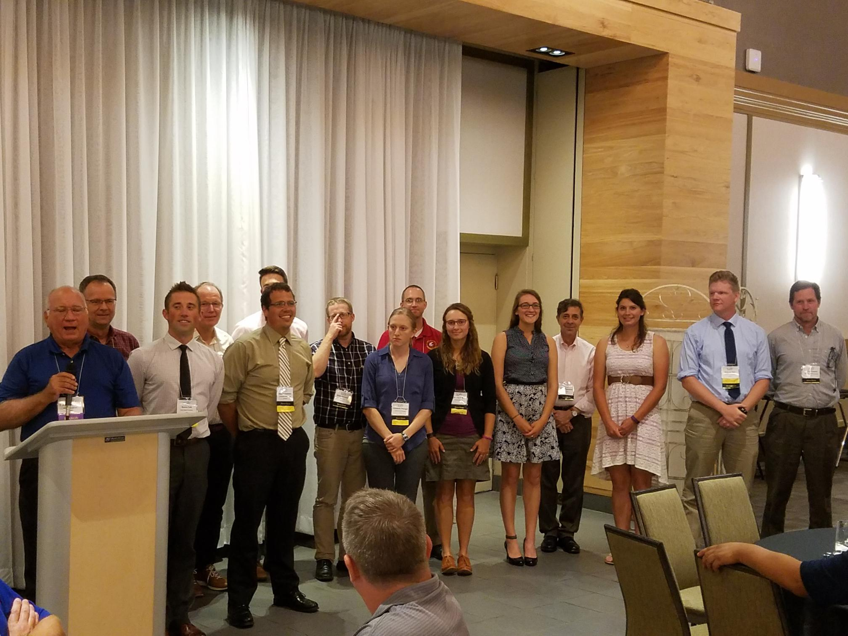

About the NAPB and PBCC
The NAPB [http://www.plantbreeding.org] is unique organization in the U.S., bringing together public and private sector plant breeders to share technical information, improve the efficiency and effectiveness of their programs, develop the next generation of scientists, disseminate information about plant breeding, and advocate for a cohesive national plant breeding agenda. The PBCC provides a forum to discuss and educate the public about Plant Breeding. Plant breeders develop new crop varieties that promote food security, quality of life, and a sustainable future.

For more information:
Jim McFerson
Chair, NAPB Award Committee
Washington State University R&E Center
Wenatchee WA 98801
jim.mcferson@wsu.edu
509-669-3900

