National Association of Plant Breeders
Early Career Working Group
August 12, 2019

2018/2019 Annual Report

The Early Career Working Group (ECWG) of the NAPB has the mission of assisting self-defined early career professionals with three primary objectives: securing professional employment and defining their career paths; providing social spaces to establish relationships with their peers; and to provide service and mentoring opportunities.
In September of 2018, the ECWG leadership transitioned and Daniel Packer and Amanda Hulse-Kemp entered as committee co-chairs and Sushan Ru as secretary. The first objective of the new leadership was to establish a mission statement for the ECWG, and the committee chairs reached out to the ECWG membership via email to request their feedback as to what they saw as the purposes of the ECWG. From that feedback, the objectives listed in the opening paragraph of this document were established as the primary mission of the ECWG and were used to inform our efforts in 2018 and 2019.
With these objectives in mind, the ECWG has the following accomplishments and activities to report in 2018 and 2019:

Securing professional employment and defining career paths:
- Hosted a webinar series titled “From Here to There: The Twists and Turns of a Plant Breeding Career”.
- Three webinars hosted in April 2019 using the NAPB Zoom account interviewing established Plant Breeding professionals about their career paths and advice for emerging professionals.
- Webinar interview participants represented professionals from private industry, academia, commodity groups, and extension (see Figure 1).
- Webinars were coordinated and hosted by ECWG members at three different institutions: Bayer Crop Science, Washington State University, and North Carolina State University/USDA ARS.
- Webinars were recorded and uploaded to two have been uploaded to YouTube on the Plant Breeding and Genomics channel.
https://www.youtube.com/watch?v=cOQijSImjCY&t=9s
https://www.youtube.com/watch?v=q4UAYxVhBM0
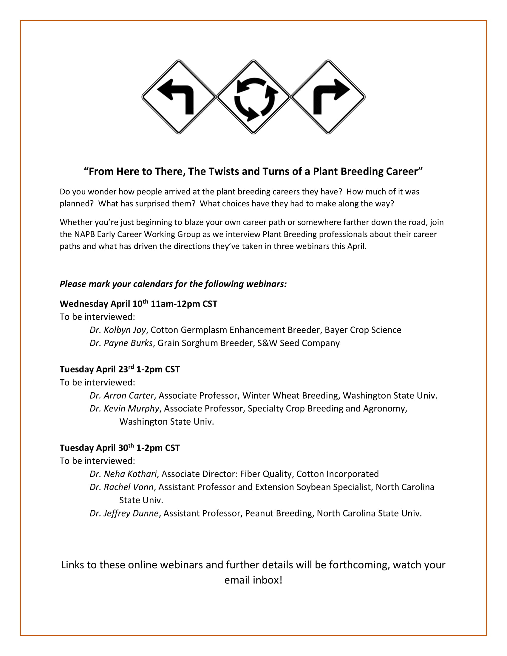
Figure 1. Flyer created to advertise the Early Career Working Group “From here to there” webinar series hosted in April 2019.

Providing social spaces to establish relationships with their peers:
- Hosted three online “Coffee Hours” in January, February, and March 2019.
  - ECWG member Sarah Potts provided the idea and template for these events.
  - Casual, online video meeting hosted on Friday afternoons.
  - Each “Coffee Hour” had a designated host in charge of establishing a meeting link, advertising, and providing conversational starts.
  - Attendance varied from 3-8 participants.
  - The ECWG intends to start hosting these again after the 2019 Annual Meeting.

- Planning social interactions at the 2019 Annual Meeting.
  - ECWG networking breakfast scheduled for Tuesday August 27 from 7-8am at the 2019 Annual Meeting.
  - ECWG member Brian Gardunia has agreed to lead this in person at the Annual Meeting.
  - ECWG group dinner and/or outdoor activity for Tuesday August 27 after the scheduled program at the 2019 Annual Meeting.
  - ECWG member Sarah Potts has agreed to lead this in person at the Annual Meeting.

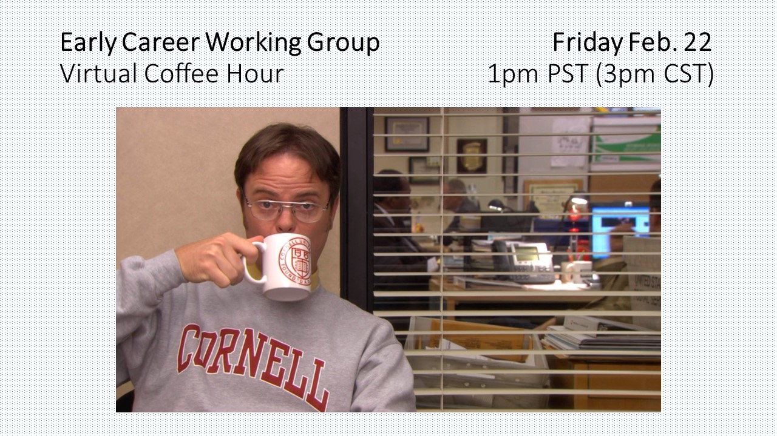
Figure 2. Flyer created to advertise an Early Career Working Group “Coffee Hour” online social event.

Provide service and mentoring opportunities:
- Coordination with the Graduate Student Working Group to provide mentoring to the Diversity Travel Awardees at the 2019 Annual Meeting.
- Four ECWG members have volunteered to provide one-on-one mentoring to four graduate student awardees.
- The mentors and mentees have been introduced to each other via email and are being encouraged to begin a dialogue before the Annual Meeting
- A mentoring breakfast is scheduled for Monday August 26 at 7am during the Annual Meeting.

