**NAPB Membership Committee Report**

**2018-19**

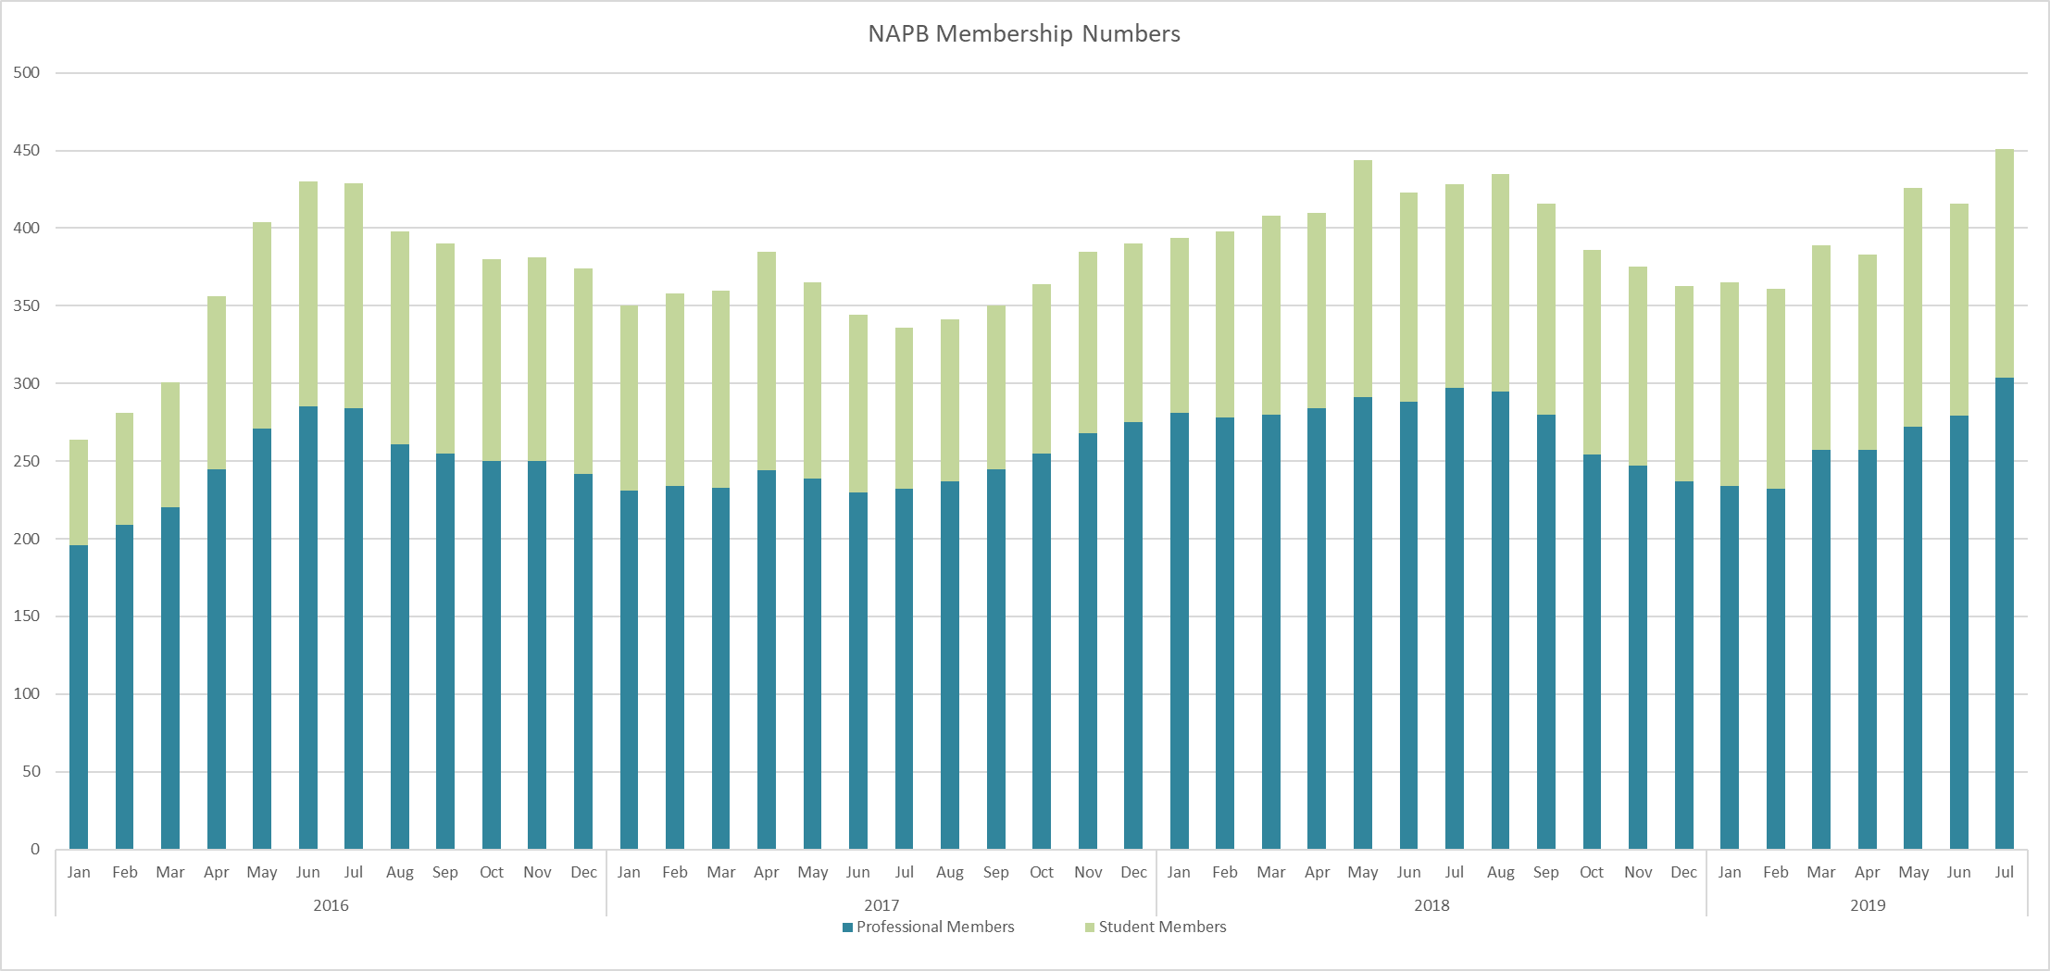

1. Numbers for July are up significantly from June, and put us at our highest membership yet (451 members, with 304 professionals and 147 students)
2. Dr. Brian Leckie has agreed to serve as our 2019-20 membership committee secretary. Our membership committee leadership is thus: Chair is Valerio Hoyos-Villegas, Vice-chair David Fang, and Secretary Brian Leckie.
3. Accomplishments for NAPB membership committee for 2018-19:
   1. Exceeded 450 members for the first time since implementing fee-based membership in 2016; at same time reached all-time high of 300+ professional members
   2. Sent business cards advertising NAPB to 8 Corteva symposia
   3. Represented NAPB with business cards or in person at 5 conferences (ASA-CSSA, ASTA-row crop, ASTA-veg, Food Security conference, Sustainability conferences)
   4. Successfully proposed increasing membership fee from $80 to $95 for professionals, and from $35 to $45 for students, to go into effect January 2020
   5. Instituted a 3rd reminder e-mail, sent directly from the NAPB President, to individuals whose membership has expired, asking them to consider renewing. This action was instituted in March, and could be one reason (along with annual meeting announcement) that membership began to increase
   6. In July, worked with ACSESS to directly contact people who registered for the meeting as non-members to ask them to join as members for no additional cost. Because they had already paid a higher price to register as a non-member, this posed a win-win situation where they could opt to become members without paying another $80, and we could gain them as members (hopefully going forward beyond just this next year).
4. Areas of Focus for 2019-20 membership committee:
   1. Increase membership to 500 members, by ~12%
   2. Currently, membership management is managed separately through ACSESS and NAPB and it causes frequent discrepancies. Goal is to work with ACSESS to improve databasing and connectivity with NAPB website.
   3. Work with ACSESS to Incorporate an auto-renew option
   4. Merge member detail update with ACSESS, currently two separate processes for updating.
   5. Improve social media presence NAPB Twitter/Linkedin. Video interviews?.
   6. Initiate a plan for recognizing long-term membership. NAPB 2020 will be 15 years since the formation of the organization. How to enourage/reward?

NAPB Membership Committee

Jennifer Yates

Valerio Hoyos-Villegas

David Fang

Brian Leckie

Donn Cummings

Hannah Senior

Johnie Jenkins

Rosalyn Shim

Gurleen Kaur