NAPB - Monthly EC and Committee Conference Call

September 18, 2018

Attendees: Bill Rooney, Emily Ziemke, Jennifer Yates; Jodi Scheffler, Zach Jones, Rob Duncan, Evan Craine, Donn Cummings, Peggy Ozias-Akins; Dave Bubeck, Wayne Smith, Don Jones, Alex Lipka, Dan Packer, Jim McFerson, David Fang, [mbkantar@hawaii.edu](mailto:mbkantar@hawaii.edu), Todd Campbell

Minutes reviewed and approved with one correction, will resubmit

Todd Campbell reviewed upcoming schedule of conference calls, alternating monthly calls between Executive Committee only and alternating with EC plus Committee chairs and officers

**September 18, 1-2pm Eastern:  Kickoff with EC, Committee Chairs, and all committee members invited**

October 16, 1-2pm Eastern: EC only

**November 20, 1-2pm Eastern: Committee Chairs report, and all committee members invited and can join at their discretion**

December 18, 1-2pm Eastern: EC only

**January 15, 1-2pm Eastern: Committee Chairs report, and all committee members invited and can join at their discretion**

February 19, 1-2pm Eastern: EC only

**March 19, 1-2pm Eastern: Committee Chairs report, and all committee members invited and can join at their discretion**

April 16, 1-2pm Eastern: EC only

**May 21, 1-2pm Eastern: Committee Chairs report, and all committee members invited and can join at their discretion**

June 18, 1-2pm Eastern: EC only

**July 16, 1-2pm Eastern: Committee Chairs report, and all committee members invited and can join at their discretion**

August 20, 1-2pm Eastern: EC only

Todd Campbell reviewed proposed tasks for NAPB committees to follow:

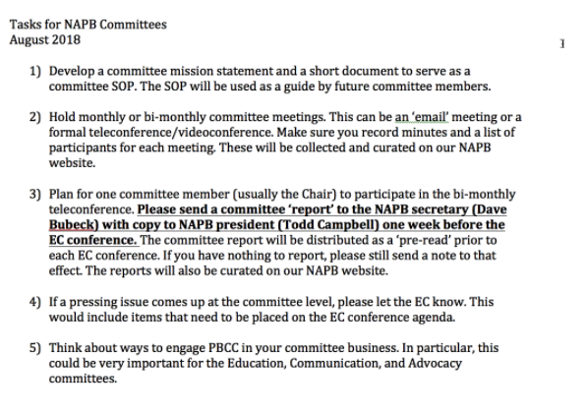

**Committee Report Highlights:**

**Financial report** – Don Jones, not available for the call, Todd Campbell reviewed financials:

Reviewed bank statement and statement of revenue and expense

Guelph NAPB meetings are not yet incorporated into this month’s statement

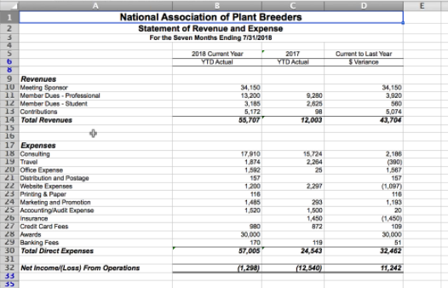

*Action: Dave Bubeck will check in with Don Jones to work with Univ. of Guelph contacts to finalize the annual meeting budget impacts to financial statements

Wayne Smith – some reoccurring expenses from non-business/academic type folks – need to determine in what months to charge to expense reports

**Membership committee** – Jennifer Yates

-increasing membership

-detailing the value of membership

-survey of members – insights to value of membership

-Jennifer will also participate in monthly Education committee

-all time high of 444 NAPB members

-student membership has maintained at about 1/3 of total members

**Advocacy Committee** - Bill Rooney

-positions and advocacy for the farm bill and inclusion of GRIN activities in the farm bill – distributed

-here to support the legislative influence according to the key areas of interest to NAPB by-laws and interest

-importance of connecting the advocacy committee to the ASTA efforts on the hill

**Education Committee** – Rob Duncan

-met on Sept. 5th, 7 members in attendance

-range of topics on report

-goals in 2018-19

-continuing webinar series and youtube channel

-highlight new and emerging technologies

-enable webinar series for continuing education credits

-focus on public plant breeding outreach

-starting work on technical skills workshop – to be held in conjunction with 2019 annual meeting

*Action - get in touch with Peggy and UGA organizing committee to detail out  the technical skills workshop

**Communication Committee** – Zach Jones

-committee meeting scheduled for the end of the month

*Action – immediate request for any additional announcements from others for the communication committee – Send to Zach by end of the day September 20th.

*Action - need to include announcement regarding 2019 NAPB meeting

**Awards Committee** – McFerson

-see request Jim just sent to us

-Specialty crops representative on awards committee – Emily suggests reaching out to Driscolls for a representative, will send their names to Jim McFerson

**Graduate student working group** – Evan Crain

-Carla will be chair until January and then Evan will become the chair

-Election will be in November for the secretary

-Works well to have someone from UGA so that we have someone from the next annual meeting site

*Action - Peggy offered to pursue a potential UGA student for the graduate student working group

*Action - Don Cummings – proposed developing a logo for the Borlaug Scholars program – suggest that the graduate student working group create the logo – students would start registering by January, so would be best to have a logo finalized by January 1, 2019 – leave logo design up to the creativity of the graduate student working group

**Early Career Working Group** – Dan Packer

-two areas of focus: 1) develop a clear mission statement to focus efforts, 2) continue to host webinars

-develop future topics for webinars

**Strategic Planning** – Wayne Smith

-met once and in process of reviewing the current strategic plan

-reviewing goals and expectations of previous 2014 strategic plan

-meeting about monthly to develop revised strategic plan

-review objectives and accomplishments of prior strategic plan

-review current mission and vision of NAPB

-cast long-term plans and benchmarks

**PBCC –** Mike Kantar

-working on big project led by Kate Evans – survey of last NAPB meetings

-strengthen linkages between NAPB and PBCC so as not to duplicate efforts

-AFRI listening sessions next month – will be represented there, getting as much publicity as possible and demonstrating why we need future investment in plant breeding; public success stories

-Thomas Lübberstedt - mine map of plant breeding curriculum – genetic core competencies, ensuring that all students coming out achieve core competencies in plant sciences

-Pat Byrne’s work on germplasm curation and developing curriculum for germplasm curation competencies, NIFA grant

**Borlaug Scholarship** – Donn C.

-ideas for going forward – growing the fund further

-sent out a news release following the Guelph meetings – useable for Seed World, ACCESS, ASTA

-preparing financial report on how the fund is growing

-need to get commitments by end of December 2018 to secure the matching funds

-communicate with NAPB EC on developing student recognition specifics at the 2019 UGA meetings

**New Business**

-Peggy – 2019 NAPB meeting in UGA – will need to start the meeting on Sunday this year due to the Labor Day weekend the following week, NIFA potential relocation outside of DC

-Plenary session on afternoon and evening of Sunday

-ASTA will have a short time on the program in one of the sessions

-consideration for 2019 housing on campus for the Borlaug scholars – will not work on UGA campus, so will consider ‘cabin’ potential arrangements – would work well to have students lodging together for networking among one another

**ASTA Update –** Bubeck – NOT discussed during teleconference

-thanks to Andy Lavigne, president of ASTA for full attendance and engagement at 2018 NAPB meetings

-continuing to build relationships between ASTA and NAPB, determine additional opportunities for positive connections

-December ASTA CSS (corn, sorghum, soybean and wheat research conference) program is nearly finalized, registration is open for the meetings; need representation from NAPB to share a moment on the main stage at CSS meetings

-Seed Science Foundation will be an ASTA sponsored foundation representing a merger of two long-standing organizations of the National Council of Commercial Plant Breeders (NCCPB) and the American Seed Research Foundation (ASRF) – will have board members that are subject matter chairs representing the following areas: Plant Breeding Systems, Plant Health/Seed Health, Digital Ag, Seed Quality and Testing, Seed Production Technology, and Seed Applied Technologies. Each Chair will be expected to assemble a sub-team of subject matter experts for each of the above six areas.